 | MON AM | MON PM | TUE AM | TUE PM | WED AM | WED PM | THU AM | THU PM | FRI AM | FRI PM | WEEKEND
MAIN HALL | Yoga  9:30 am -11:30am  See Office for information  Healthy Hearts  11.30am – 12.15pm  (Free For September) | Kidz Club (Free)  3:30 pm –5:00 pm  Reception-year 4  Let’s Sign Together!  1:30 pm – 2:30 pm  £3 per family  Youth Club (Free)  5:30 pm –7:00 pm  Year 5 onwards  Tai Chi  7.15 pm –8.15 pm  Contact: Susie £5 in advance /£6 on the day |  | Community Tea  4:30pm – 5:30pm  FREE  Playgroup for.. Dogs!  7pm – 8pm  £1 Per Dog | Fit & Fabulous  9.30am –10.30am  FREE | Puddle Ducks Playgroup  1:00pm – 2:30pm  £1 Donation  Kidz Club (Free)  3:30 pm – 5:00 pm  Reception to year 4  Youth Club (Free)  5:30 pm –7:00 pm  Year 5 onwards | Yoga  9:30 am – 11:30am  See Office for information | Teen Dance  6pm-6.45pm  Bokwa Adult Fitness Dance  7:00pm 8:00pm  £5 per session no booking required  Adult Dance Fit Fusion  8:00 pm -9:00pm  £5 per session no booking required | The Active Windhill Initiative  10:00 am – 3 pm  All Activities Free  Dancercise, Table Tennis, Pool, Darts, Chess, Bingo, Storytime  Bumble Tots  9am – 12pm  Booking only.  More info visit  www.bumbletots.co.uk | The Active Windhill Initiative  10:00 am –  3 pm  All Activities Free  Dancercise, Table Tennis, Pool, Darts, Chess, Bingo, Storytime
INDOOR |  | Job Club  1.30pm – 3.30pm  FREE TO ALL | HFT  JOB CLUB  9am – 3pm | Work Ready  1pm – 3pm  Job related support | Basic Maths and Finance  9am – 11am
OUTDOOR |  |  |  |  |  |  |  |  | £1 for Lunch | £1 for Lunch
LOUNGE | Adults Read and Writing support  10:45 am – 11:45 am  Free. All welcome | Healing Hands  12:00 pm – 3:00 pm  Donations  Welcome  Knitting & Crochet  6pm – 8pm | GCSE Maths  9:00am–12:30pm  Enrol through Shipley College by September  2018 | Family Links  2pm – 4pm | 55+ Tablet Training (Free)  11 am – 1 pm  Booking required | Functional Skills Maths/English  Level 1 to GCSE  1:00 pm – 3:00pm  Free |  | Creative Writing  Kids 4pm – 5pm (£3)  Adults 5pm – 6pm (£5)
 | MONDAY TO FRIDAY  FOR MORE INFORMATION, PLEASE PHONE 01274 588831 OR EMAIL… |  |  |  |  |  |  | NEWS  Windhill Community Centre Charity NEWCA
ADVICE | DAILY BY APPOINTMENT |  | FREE |  | contact@windhillcommunity.co.uk |  |  | Police Pcso Jaggers - 07713708364
Café | 9:00 am – 2:00 pm |  | See menu for prices  FREE CEREAL, TOAST & DRINK  9.00 AM – 10:30 AM |  | Karina.addy@windhillcommunity.co.uk |  |  | Local Councillors – Vanda Greenwood  Susan Hinchliffe, Alex Ross Shaw
ICT ROOM | UK Online  9:00 am – 4:00 pm |  | FREE |  | contact@windhillcommunity.co.uk
Nursery | 8:30 am – 3:30 pm |  | Free Subject to eligibility, plus paid & top up slots available. |  | samantha.lee@windhillcommunity.co.uk |  |  | Please share our facebook page!!
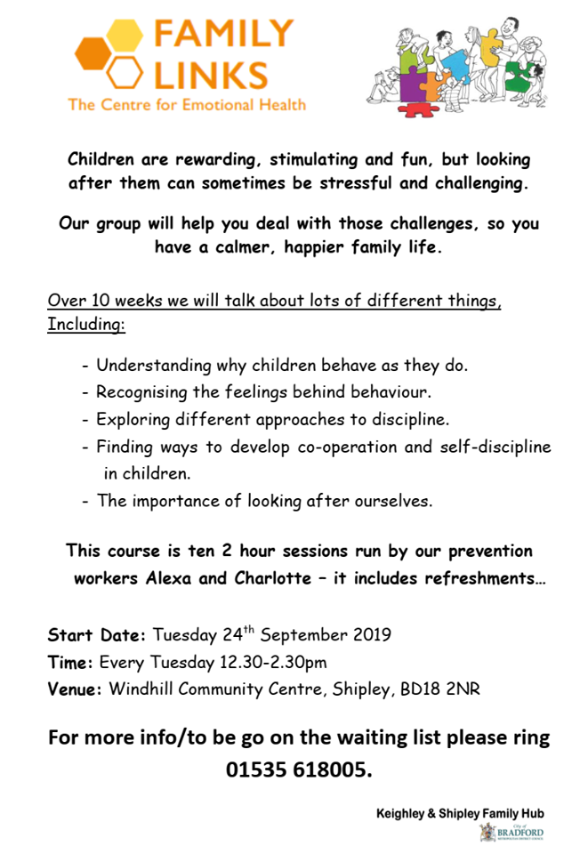
SPECIAL EVENTS FOR THIS MONTH!
SPECIAL EVENTS FOR THIS MONTH!

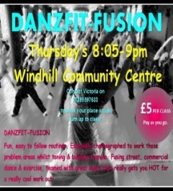
ON DISPLAY IN THE RECEPTION AREA…

