 | MON AM | MON PM |  | TUE AM | TUE PM | WED AM | WED PM | THU AM | THU PM | FRI AM | FRI PM
MAIN HALL | Yoga  9:30 am – 11:30 am  See Office for information | Dance for life  1:30 pm –2:30 pm  Parents & children  Free  Kidz Club (Free)  3:30 pm –5:00 pm  Reception-year 4  Kidz Club (Free)  5:30 pm –7:00 pm  Year 5 onwards  Tai Chi  7.15 pm –8.15 pm  Contact: Susie £5 in advance /£6 on the day |  |  | Debut Dance  5:30 pm – 8:30 pm  Ask Office for information.  Dru Yoga  1:30 pm – 2:30 pm  £5 per week monthly  or £6 per class pay as you go | 55+ Tablet Training  12 pm – 2 pm  Booking required.  Free  Fit & Fabulous  9.30am – 10.30am  Shipley Men’s Forum (Free)  10.30am–12.30pm  Windhill Walk  11am -12 Midday, followed by Free Light Lunch in the Café | Kidz Club (Free)  3:30 pm – 5:00 pm  Reception to year 4  Kidz Club (Free)  5:30 pm – 7:00 pm  Year 5 onwards  SEE SPECIAL EVENTS for more information about Wednesday Afternoons | Yoga  9:30 am – 11:30 am  See Office for information  Womens Self Defence  11:30 pm – 12:30 pm  £5 per session no booking required | Bokwa Adult Fitness Dance  7:00pm – 8:00 pm  £5 per session no booking required  Adult Dance Fit Fusion  8:00 pm – 9:00 pm  £5 per session no booking required | The Active Windhill Initiative  9:30 am – 3:30 pm  Keep fit, Chess, Table Tennis, Cards, Dominoes Dance and Craft.  All Activities Free  Job Club  10:00 am – 12:00 pm  Free | The Active Windhill Initiative  9:30 am – 3:30 pm  Keep fit, Chess, Table Tennis, Cards, Dominoes Dance and Craft.  All Activities Free  Job Club  10:00 am – 12:00 pm  Free
INDOOR |  |  |  |  | Tai Chi  7:00 pm – 8:30pm  Contact: John or Susie |  |  |  |  | Donation of £1 for Lunch | Donation of £1 for Lunch
OUTDOOR |  |  |  |  | The Big Swing  Adventure play  3:30 pm - 5:30 pm  Windhill Wild Park
LOUNGE | Adults Read and Writing support  10:45 am – 11:45 am  Free. All welcome | Healing Hands  12:00 pm – 3:00 pm  Donations  Contact: Val on 01274 580633 |  | GCSE Maths  9:15 am – 12:30 pm  Enrol through Shipley College before September | Let’s Sign Together!  1:30 pm – 2:30 pm  £3 per family |  | Functional Skills Maths/English  Level 1 to GCSE  1:00 pm – 3:00pm  Free | Crafty Folk  9:30 am – 11:30 am  £1 Donation. All welcome. Any ability. |  | Craft: Paper Mosaic  1:00 pm - 3:30 pm  Free | Craft: Paper Mosaic  1:00 pm - 3:30 pm  Free
 | MONDAY TO FRIDAY  FOR MORE INFORMATION, PLEASE PHONE 01274 588831 OR EMAIL… |  |  |  |  |  |  |  | SPECIAL EVENTS ON  WEDNESDAYS
ADVICE | DAILY  BY APPOINTMENT |  | FREE |  |  | contact@windhillcommunity.co.uk |  |  | 1st Wednesday – Tea Dance
Café | 9:00 am – 2:00 pm |  | See menu for prices  FREE CEREAL, TOAST & DRINK  9.00 AM – 10:30 AM |  |  | Karina.addy@windhillcommunity.co.uk |  |  | 2nd Wednesday - Film Afternoon
COMPUTER ROOM | UK Online  Support Centre  9:00 am – 4:00 pm |  | FREE |  |  | contact@windhillcommunity.co.uk |  |  | 3rd Wednesday – Magic Memories
Little Ducklings Nursery | 8:30 am – 3:30 pm |  | Free Subject to eligibility.  Paid sessions & top ups also available. |  |  | samantha.lee@windhillcommunity.co.uk |  |  | 4th Wednesday – Women’s Wellbeing Wednesday

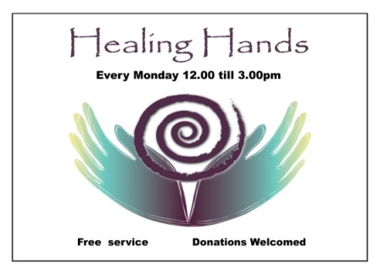
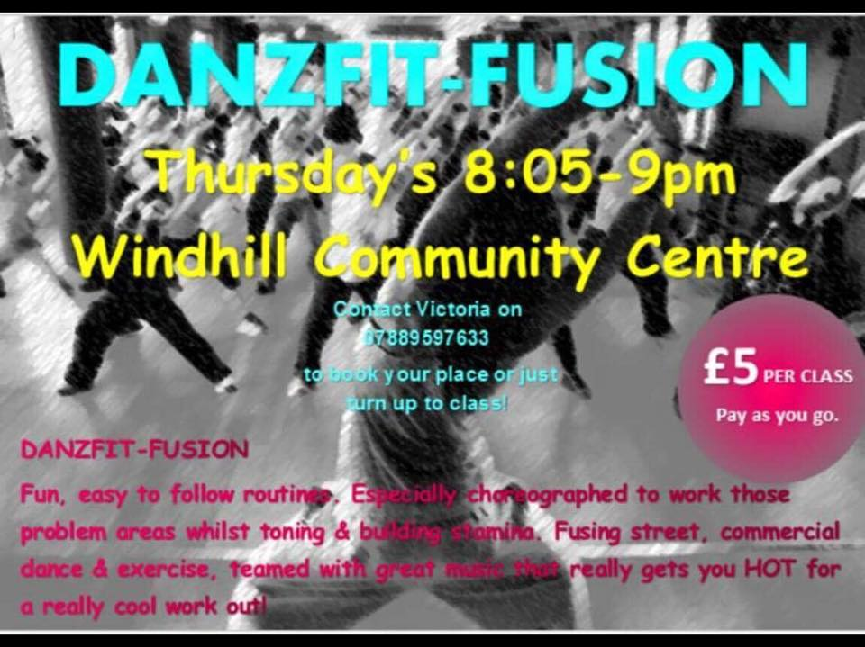
SPECIAL EVENTS FOR THIS MONTH!

ON DISPLAY IN THE RECEPTION AREA…
Crafty Folk

