[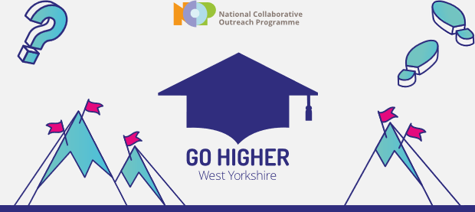](https://s6.newzapp.co.uk/t/gtl/MTI1OTkyODgsMTIxMTMzNjQ5OSwxNA==)

Go Higher West Yorkshire Drop-In Employment and Education Sessions

About Our Sessions

* Aged 13-19?
* A parent of a 13-19 year old?
* Not sure where to take your career or how to advise your child on Higher Education or apprenticeships?
* Need 1-1 support and advice?
* WE CAN HELP!

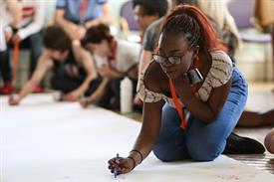

Further Details

Do you think Higher Education isn’t for you and your family? Let us prove you wrong! Higher Education doesn’t only mean university- come and learn more about options for Apprenticeships or College/University Courses.

Go Higher West Yorkshire is a project that raises aspirations, motivation and gives advice and support to parents and Young People about their futures.

The sessions will provide Information on Higher Education and apprenticeships for parents and Young People

* Date & Time

Starting 4th October 2017

4-6pm every Wednesday

 Location

Windhill Community Centre  
Church St, Bradford

BD18 2NR

