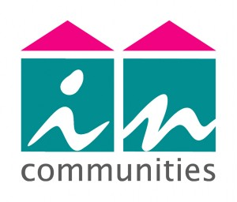

**Do you need a qualification to help you gain employment or to enrol on a college course?**

**Then why not attend our free maths and English workshops for adults**

**These classes run on a Wednesday afternoon every week between 1.30pm – 3.30pm**

**Learning Opportunities at Windhill Community Centre for Incommunities tenants**

**If you want more information or you would like to be added to the register then contact Nicki on 01274 254739 or email nicki.woods@incommunities.co.uk**

**Are you looking to improve your maths and English skills?**