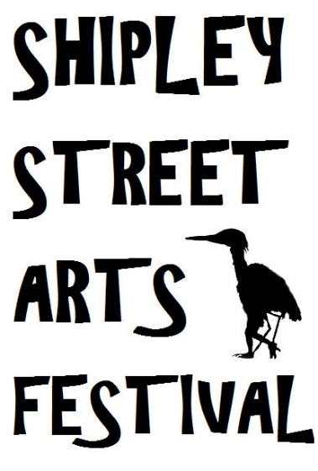 | SHIPLEY  STREET ARTS FESTIVAL  AT  WINDHILL COMMUNITY CENTRE  Church Street, Shipley BD18 2NR

Make it happen! Get involved! Volunteers required!
We are delighted to announce that once again North East Windhill Community Association has been invited to take part in this year’s Shipley Street Arts Festival. We would like you to come along and help out with the events that we will be putting on before, during and after the Festival once Shipley Street Arts Festival announce their line up.
Please phone 01274 588831 or call in at the Centre and ask for Tim, Jeff or Gianfranco to find out how to become involved.

Shipley Street Arts Festival is working in collaboration with Yorkshire Festival and Without Walls Street Arts Consortium (www.withoutwalls.uk.com) to bring you some truly AMAZING headliner acts!
They will be announcing their line-up in a few weeks, so keep your eyes peeled for some brilliant street theatre entertainment, coming to Shipley in July of this year.

This year's dates are Friday 1st, Saturday 2nd and Sunday 3rd July 2016.
The theme for 2016's @Shipley_Fest is ... STORYTELLING.
Tell us a tale!

SHIPLEY  STREET ARTS FESTIVAL | 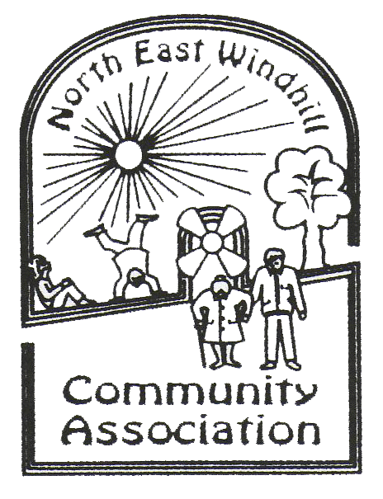 | WINDHILL COMMUNITY CENTRE

