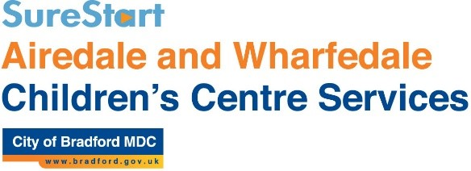

***::Downloads:Sign & Write BSL Early Years Graphics-2:BSL Line Drawings:BSL Early Years:welcome.emf::Downloads:Sign & Write BSL Early Years Graphics-2:BSL Line Drawings:BSL Early Years:sign.emf***

Let’s Sign Together!

**Would you like to…**

**Enjoy communicating more with your child?**

**Learn simple BSL signs to use everyday?**

**Build self-esteem and lessen frustration?**

**Have fun sharing songs and stories with your child/ren?**

**Let’s Sign Together**

**is a 8 week introduction to signing with your child.**

**It’s simple and fun – with experienced and friendly tutor,**

**Rachel McMahon. All welcome - from baby to toddler.**

**At : Windhill Community Centre, Church St, BD18 2NR**

**Starts: Tuesdays 1.00pm – 2.30pm for 8 weeks**

**From: 6th June to 25th July**

**Cost : £3 per session**

**For more info contact Airedale and Wharfedale Children’s Centre Cluster on 01535 605272 - or just come along and join the fun!**